**I believe you're a Dragon**

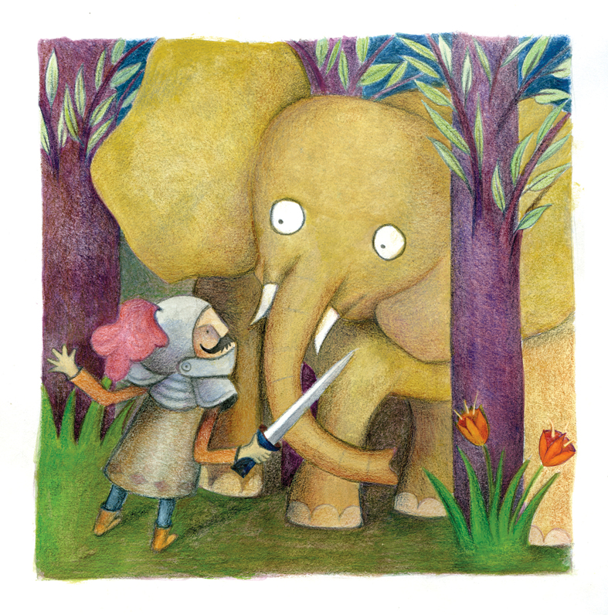

By: Nava Libman-Perlov

There was a common lizard

Upon a hill nearby.

It pondered and it wondered:

What in the world am I?

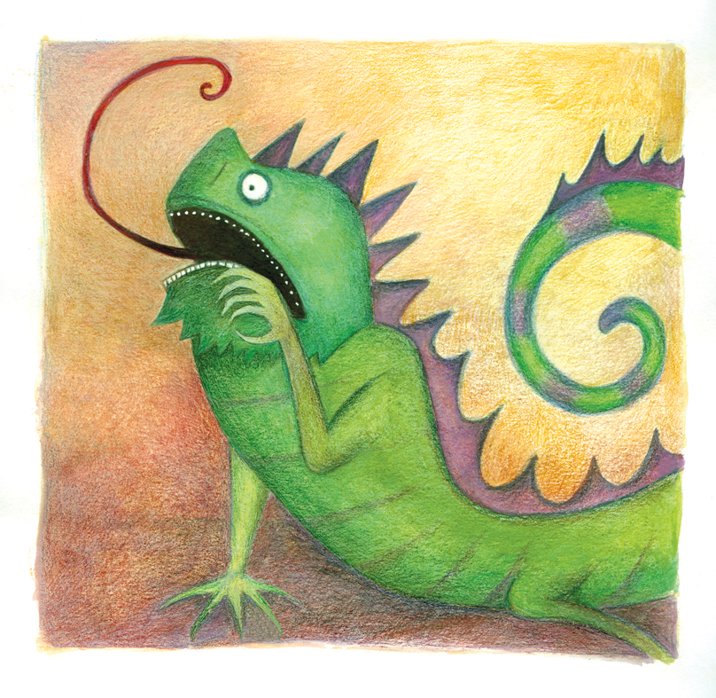

I’m clearly not a bird,

It’s plain to comprehend:

I have no wings, I have no beak,

I cannot fly nor land.

I also cannot be a fish,

It’s easy to declare,

For fish that leave the water’s reach

Are so extremely rare...

The lizard puffed its scaly chest,

It bared its sharp claws out:

“I am a terrifying brute –

A beast, without a doubt!

## “Behold all creatures, big and small”

The lizard then announced,

“I am a dreadful monster,

A ‘Dragon’ it’s pronounced”.

And all creatures, near and far

Did hear the lizard’s speech,

They shivered top to bottom, knelt,

And kept out of its reach.

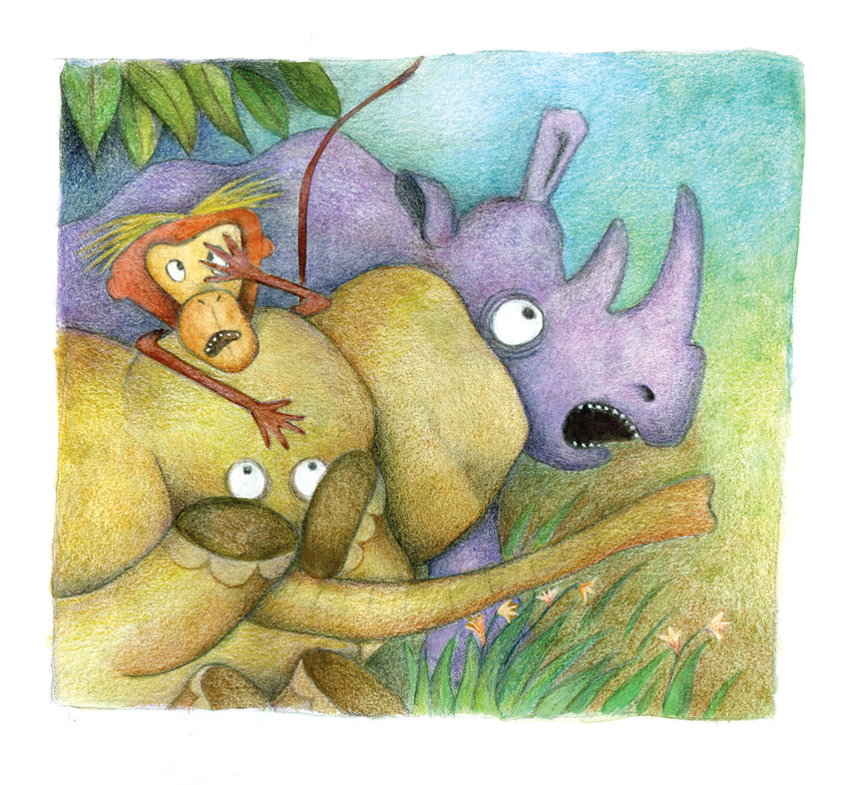

And so the rumor swiftly spread -

For that’s how rumors are:

They drip and leak and grow ahead

And travel very far.

And so the whisper, soon enough,

Had echoed all the way

Until it reached the mighty knight

Whose name is: “Save-The-Day”

Sir Save-The-Day had lived a life

Which was a lasting bore:

Without a single daring deed

To be remembered for!

At last!” Sir Save-The-Day cried out,

“I finally have my chance!

To don my knightly shining shield

And my gigantic lance!”

His equipment at the ready

Upon his horse so tall,

Although one thing still was missing

But what? He can’t recall

And just as he was stepping out

All dressed up for his hike,

He realized he had not a clue

What a dragon looked like!

# “Oh, that won’t be a problem, no!

I’ll take this latest book:

#### Called, ’10 steps to find a dragon”,

To help me as I look.”

He made to turn a few pages

But his patience was slight,

## So he quickly galloped away

Into the dark of night.

He bumped into a hulking beast

Amongst the towering trees:

Its ears were like big blowing fans,

Its nose hung to its knees.

“I believe you are a dragon”

Sir Save-The-Day declared:

And now, if you’ll forgive the slight,

Your life cannot be spared”



“Well, sadly I am no dragon”

The creature said, amused,

“Although indeed I understand

How you could be confused.”

“Besides”, the elephant added

After a little pause:

“Dragons, according to science

“Have razor-bladed claws.”

Sir Save-The-Day then slowly stared

At the elephant’s feet:

“A pity,” he then softly said.

“But it was nice to meet!”

*

He later met a being strange

Atop a distant hill,

And at the sight of its great claws

His heart was filled with thrill:

“Excuse me,” asked Sir Save-The-Day,

Curious but polite,

“Do you happen to be a Dragon?

Is there any chance you might?”

The peculiar being groaned

And cried:” this is absurd!

You are the first to *ever* mix

A dragon and a bird!”

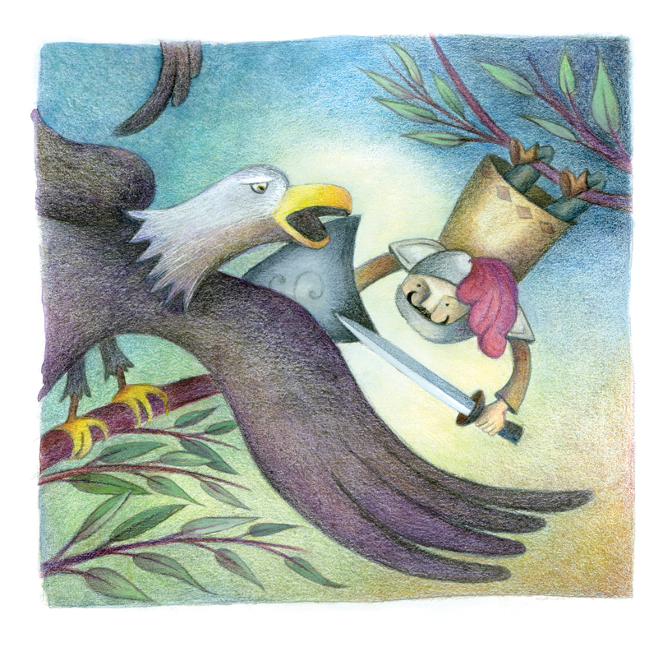

“What are you, then,” asked Save-The-Day,

If not some kind of dragon?

For I can see as clear as day

Your razor-bladed talon!”

It said, “I am an eagle, sir,”

And gave another clue:

“Dragons are covered up with scales.”

...Then spread his wings and flew...

Save-The-Day was disappointed;

There’d been such a delay!

“A pity” he then said aloud,

And galloped fast away.

Exhausted and weary he sat,

Muttered a bitter sigh,

Then spotted a scaly creature

Out of the corner of his eye:

“You seem pretty big, I daresay

And you’re scaly as well...

But could you be a *dragon*, though?

It’s very hard to tell!”

"What am I?” the strange creature said,

“You’re making such a fussss!

Is that the important topic

of which we should discussss?”

"Are you the dreadful Drake or not?

Just tell me right away!

”I am a very *busy* knight!”

Shouted Sir Save-The-Day.

“I am a snake,” the snake confessed,

And Save-The-Day could trace

The mocking smile that smeared upon

Its spiteful little face...

“Oh,” Sir Save-The-Day said quiet,

With nothing left to say,

Then slowly remounted his horse

And, flustered, rode away.

It was the middle of the day

Upon the hill nearby;

The sun was burning bright and hot,

The earth was cracked and dry.

And at the end of the long trail,

There the dragon was:

All big, and green and full of scales,

With razor-bladed claws.

“I believe you are a dragon,”

Said our travel-weary knight.

“So they say,” the lizard answered,

With unconcealed delight.

"At last!” cried gleeful Save-The-Day,

“I’d almost lost all hope!”

Then quickly tied the dragon up

With a frayed piece of rope.

Excited and proud, sweaty and flushed,

Into the royal palace he rushed.

He put his lance aside,

And knelt down on his knees:

“My king, I’ve brought this dragon here

To do with as you please”

But with a smile the king replied:

"My knight, I must have proof

That is a dragon standing here

Under my royal roof!

To prove to me it’s not a fake,

nor you a common liar,

#### Would it, very kindly

Spit some blazing fire?”

...”I can try” the lizard mumbled,

“If that is your desire”…

He stood before the king with pride

On both his dragon-feet,

# But even-though he tried so hard

His mouth sprayed naught but spit...

“Oh,” said the king

Wiping his face:

“You are no dragon!

You’re a disgrace!"

The king then mocked Sir Save-The-Day:

“A wonder you survived;

A common lizard you have brought -

You’re the bravest knight alive!”

As the humbled knight left the hall,

A new rumor took flight:

The vicious dragon was defeated

By the glorious knight!

No one knows how this rumor started,

Or why sir Save-The-Day never shows his face

Both he and the Dragon have gone missing

Without leaving a single trace.

In truth the knight, with scaly beast,

Left town upon a wagon

And had adventures with the friend

He once thought was a Dragon.

**The End.**